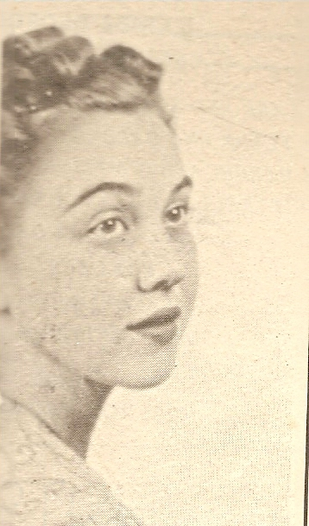
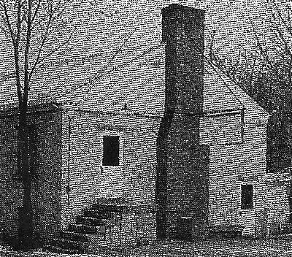
Remembering:
Suzanne V. Bruce - circa 1958
“Sue” and Kenny Bruce and Hi-Teen, 1950’s - 60’s
By Chuck E. Ledbetter, Sr.

Mrs. Suzanne V. Bruce was Charlestown Director of the Community Building for several years before my family moved to Charlestown from New Albany in 1955. Her husband, Kenneth ‘Kenny’ Bruce worked alongside her during those remarkable days as a teenager maturing in Charlestown.
If you were on the scene and one of the lucky teens in those days of Charlestown, the Hi-Teen was the place to be! I say lucky because “Sue or Mrs. Bruce”---as she was affectionately called---was just like a second mother. I am sure she assisted many a young person in making the right decisions before an evening was through.
In her role as the recreation director of the Charlestown Hi-Teen she did it with real love and compassion. The younger generation looked up to her and they knew she would take a genuine interest in their problems no matter what they brought to her. She would always take the time to listen.
Charlestown Hi-Teen – circa 1950’s
The Hi-Teen was a teen organization dedicated to bringing various activities for the youth attending high and junior-high school and residing in Charlestown. Every Friday and Saturday evenings teenagers would congregate at the Hi-Teen and dance to their favorite music, play ping-pong, shoot pool, cards, etc. under the leadership of the Bruce’s.
Upstairs in a small white two-story concrete building, “Sue” would be seated near the entrance of the door meeting and greeting young patrons as they entered the establishment on Harrison Street. Today, it’s no longer there. The property the white block building was erected on was sold to a local organization and removed.
The dance area was doused with powdered resin sprinkled on the floor to help glide the young dancers with their gyrations as the music blared from the jukebox. There was a lot exciting jitterbugging and slow dancing by young couples who enjoyed being with each other on the weekends. The dance floor was always active until closing usually around 10 pm.
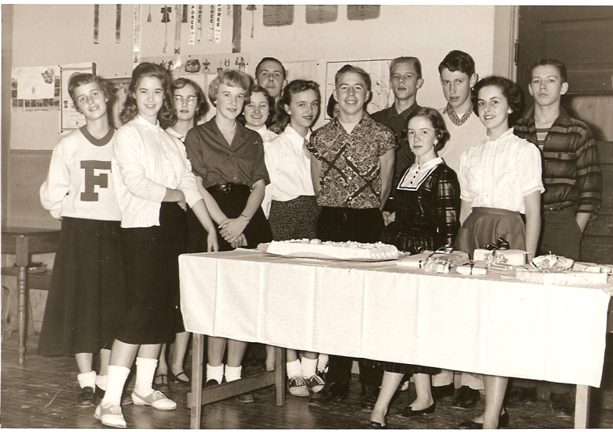
Downstairs different games and various activities were underway with the guidance of Kenny Bruce. You could see the competition between the younger generation playing ping-pong, pool, and cards in sportsmanlike nature. Very seldom in the history of the Hi-Teen did the youth group encounter inside or outside trouble, but if it did occur, Kenny---who was with the Indiana State Police working as a dispatcher at the Indiana State Police post in Charlestown---would squelch any problems that arose.
Tony Kochersperger’s Birthday Party at Hi-Teen – circa 1958
Front row - L-R: Jill Benson, Sandy Conard, Sharon Turner, Marlene Bruce, Tony, Marilyn Phillips, Mary Bourne. Back row - L-R: Roberta Olges, Sandy Conard, Carol Mudd, Steve Kochersperger, Chuck Ledbetter, John Hartlage, and an unidentified person.

Come Monday morning heading back to school the youth would rave about their experiences at the Hi-Teen. This would last throughout the week, and when the weekend approached it was time to cheer on the high school basketball teams. Usually, depending on whether or not the game was played on a Friday or Saturday night, the youth of Charlestown would congregate at the Hi-Teen for more dancing to the most recent hits, or just having an enjoyable time with their classmates.
The Hi-Teen served its purpose all those years, but if it hadn’t been for people like, Sue and Kenny Bruce, and Mrs. Pauline Kochersperger, life would have been rather dull growing up in Charlestown.
In March of 1958, Mrs. Suzanne V. Bruce passed away at the age of 40 after a long painful bout with cancer. Her death was a stunning blow to the community. She had contributed so much to the community’s youth programs. In addition to her work as recreation director, she was active in Girl Scout work. Even though she found time for outside events, she was a devoted wife and mother first. She expected, and received much from her children in the way of scholarship.
Mrs. Suzanne V. Bruce was a graduate of Indiana University and a member of the Charlestown Presbyterian Church. She had one daughter, Marlene, and one son, Kenneth Ray Bruce, when she died. Kenneth, her husband, passed away years later. They are buried in Charlestown Cemetery.

Mrs. Bruce was replaced by Mrs. Pauline Kochersperger, who was the director until her death in 1965. She was a dedicated person who was well-known in the community for supporting the youth. She was married to Glenn Kochersperger and had four sons; Roger, Anthony “Tony,” Steve, and Mark. Mr. Kochersperger passed away in 1973, and their oldest son, Roger died in 2000. Dorothy Hassfurther became the new director of the center until it closed. Steve and Tony are 1961 graduates of Charlestown High School.

